# **The International School Bangalore**

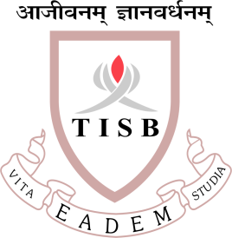

**Syllabus outline Grade 11 entrance test**

1. States of Matter
2. Atoms and Elements
3. Atoms Combining
4. Reacting masses and Chemical Equations
5. Using moles
6. Redox Reactions
7. Electricity and chemical change
8. Energy changes in reactions
9. The rate of reaction
10. Reversible reactions and equilibrium
11. Acids and bases and salt
12. Periodic table
13. Metals
14. Nonmetals and their compounds
15. Organic chemistry
16. Polymers
17. Ions and gases

**QUESTION PAPER PATTERN**

· Nature of Questions: Multiple Choice Questions (MCQs)

· Number of Questions: 15

· Duration: 20 minutes

**LINKS TO QP & MS**

[Grade11 Chemistry Answer Key.docx](https://nafltrust-my.sharepoint.com/:w:/g/personal/admission_tisb_ac_in/EeSQvNd1bONEp3BycBa17WoBIWgPlX9jIBE7XqdsOr0Epw?e=H7nGpM)

[Grade 11 Chemistry Entrance Test Paper.docx](https://nafltrust-my.sharepoint.com/:w:/g/personal/admission_tisb_ac_in/EVVbuUK4N4ZPjvarkBGj0g8Bsx6vJdPjqS4n0BuYeJyMUg?e=ciPvR9)**12**